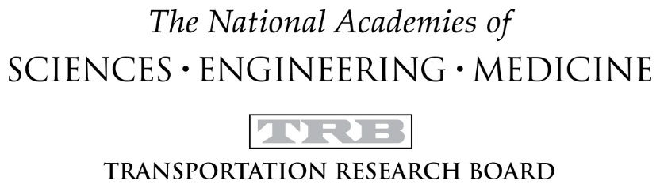

Intergovernmental Relations in Aviation Committee (AV010)
Subcommittee on Commercial Space Transportation (CST)
2016 Annual Meeting
Tuesday, January 12, 2016
8:00-9:45AM
Marriott Marquis Hotel

MEETING AGENDA

- Welcome and Attendee Introductions – Wil Laska
- Presentation: An Overview of the Mid-Atlantic Regional Spaceport and the Role of State Spaceports in Transportation; Mr. Thomas Shearer, Director of Business Development Virginia Space and the Mid-Atlantic Regional Spaceport (MARS)
- Updates (based on availability – schedule may adjust)
  - TRB Update – Christy Gerencher
  - Research Coordinator – Ken Davidian, Dr. William Tippin
  - Membership Coordinator – Rick Rogers
  - Planning Coordinator – Dr. Marcus Smith, Dr. Diane Howard
- Subcommittee Volunteers – Wil Laska
  - Secretary
  - Communications Coordinator
- 2017 Annual Meeting Session/Workshop Development – Wil Laska
- Adjourn

