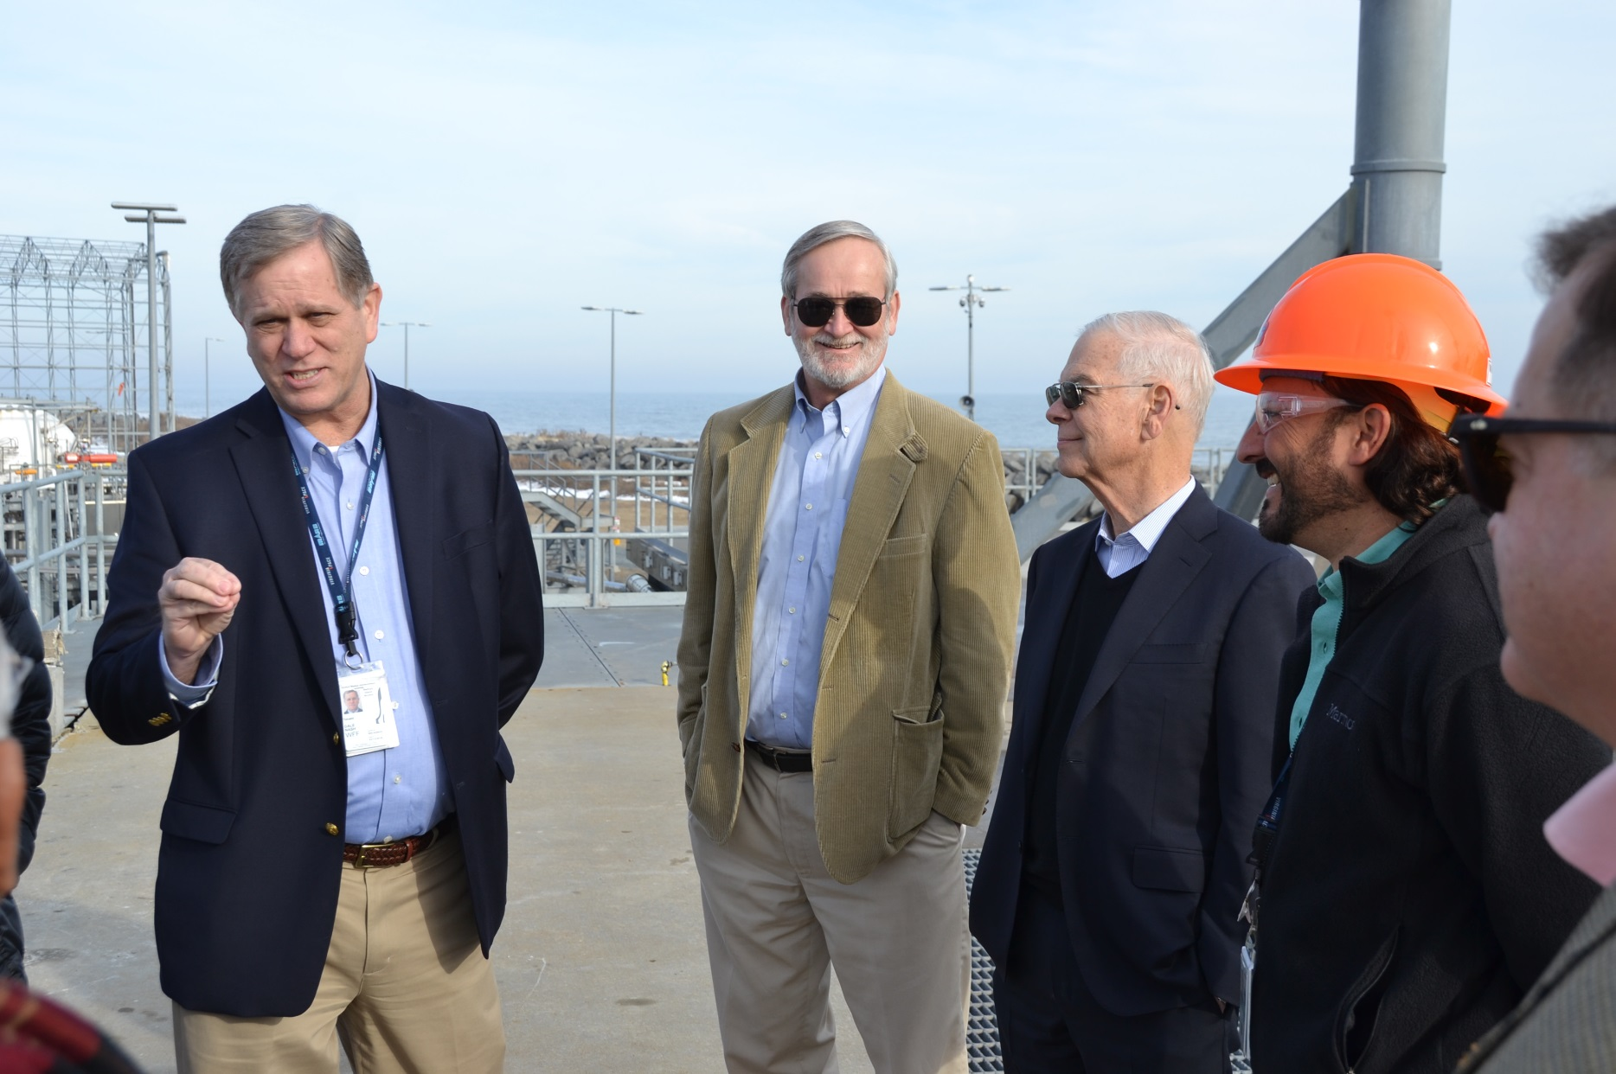
At Wallops Flight Facility and Mid-Atlantic Regional Spaceport (MARS), January 11, 2017
Left to right: Dale Nash (Executive Director, MARS), Wil Laska (Chair, Subcommittee on Commercial Space Transportation, National Academy of Sciences), Bob Seibold (Senior Project Leader, Aerospace Corporation), Luis Arroyo (Chief Engineer, MARS), and (partial profile) Frank Slazer (Vice President, Space Systems, AIA)

